Problem 1:

Write a C program to take input of three subject marks (integers) from the user. The program should calculate the total marks and the percentage (out of 300). Display the results with 2 digits after the decimal point.

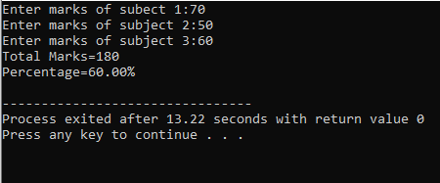

Problem 2:

Write a C program to input two integer variables and swap their values and print the values after swapping.

This is how it looks like after swapping.

Input → a = 10, b = 20

Output → a = 20, b = 10

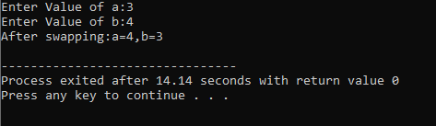

Problem 3:

Write a C program that takes an integer (between 65 and 90) as input and prints:

1. The integer itself

2. Its corresponding ASCII character

Input → 65

Output → 65 = A

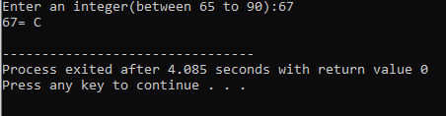

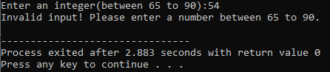

Problem 4:

In a company, an employee’s salary is calculated by adding certain allowances to the basic salary. Two types of allowances are considered: House Rent Allowance (HRA): 10% of the basic salary , Dearness Allowance (DA): 5% of the basic salary Write a C program that:

1. Takes the employee’s basic salary (a float value) as input.

2. Calculates the values of HRA and DA.

3. Computes the Gross Salary using the formula:

Gross Salary = Basic Salary+HRA+DAGross

Displays the Gross Salary with exactly 2 digits after the decimal point.

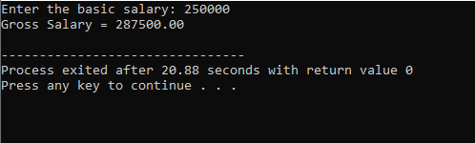

Problem 5:

Escape sequences in C (like \n, \t, \") are used to format text output. In this task, you will practice using escape sequences.Write a C program that displays the following details exactly in the same format as shown below:

Name: Ali

Age: 20

Course: "C Programming"

Result: Passed

